RWANDA EDUCATION BOARD (REB)
PRIMARY FOUR CONSOLIDATED ENGLISH EXERCISE
- Order the words to make meaningful sentences ( 1mark)
- Favorite, English, is, my, subject
…………………………………………………………………
- Foot, Keza, goes, to, school, on
…………………………………………………………………
- Songs, at school, I, everyday, sing
……………………………………………………………..
- A pilot, I, like, to be, would
…………………………………………………………..
- A cow, in, We, the, saw, farm
………………………………………………………….
- Fill in the dots with the correct preposition from the bracket(2marks)
- Kate goes to school …………………………bus (on/ by/ with)
- It was made ……………………………….the 1990s (on/ in/ by)
- The story was written ………………………………William (by/ in/ at)
- She threw a ball ……………………………… me ( in/ into/ at)
- The cat ran …………………………….. the house (outside/ at/ by)
- The old man is suffering ……………………..malaria (from/ at/ for)
- Will you please fill this bottle ………………….milk? (by/ with/ in)
- Divide this orange ……………………….two boys (to/ for/by)
- Mother came ………………………uncle John (in/with/ by)
- Aren’t you ashamed ………………….such behavior? (of/ from/ to)
- Replace the underlined nouns with the appropriate pronouns from the bracket (2marks)
- Peter works at the hospital (he/ him)
……………………………………………………………………………..
- That dog runs very fast (it/ you)
.............................................................................
- The headmaster advised us to work hard both at school and at home (it/he)
………………………………………………………………………………………..
- Kate and Kenny are brothers (they/ them)
........................................................................................
- Paul and I will go to the shop (us/we)
……………………………………………………………………….
- Dad brought Kevin and I very good presents (us/we)
…………………………………………………………………………………………..
- She wanted to play volleyball with John (he/him)
………………………………………………………………….
- The police arrested the thieves ( they/them)
………………………………………………………………………
- The school rewarded Lenny and his brother for the job well done (they/them)
………………………………………………………………….
- Children are playing football in the school yard (they/them)
………………………………………………………………………
- Rewrite the following sentences with the correct plural form of the word in bracket (1mark)
- My father’s clothes had (louse)
……………………………………………………………………
- The old (woman) listened to birds singing in the morning
………………………………………………………………………..
- These (boy) are smart
……………………………………………………………………….
- The (man) were riding a blue bicycle
……………………………………………………………………….
- Mummy buys (sandwich) every morning at the bakery
…………………………………………………………………..
- Write common noun or proper noun on each of the underlined nouns (2marks)
- Joana has a very good hand writing
.........................................................................................
- Bad children were throwing stones at the passers-by
……………………………………………………………..
- The government urged us to stay home in order to slow the spread of corona virus
…………………………………………………………………………..
- The man was riding a blue bicycle
…………………………………………………………………………
- Kigali is a clean city
………………………………………………………………………..
- Fill in with the correct tense of verb as instructed in the (…..) (2marks)
- Last week it …………………………..rainy (be: simple past tense)
- I ………………… English notes every day ( write: simple past tense)
- My brother ………………………………………. to do the homework yesterday (help: simple past tense)
- Sano …………………………………………….. at me and laughed (look: simple past tense)
- He …………………………………………… home next week (come: simple future tense)
- John and I ……………………………………football last Monday ( play: simple past tense)
- Jane …………………………………………………delicious food yesterday (cook: simple past)
- Our class ………………………………………………..sports every Friday (do: simple present tense)
- Kalisa …………………………………………………… his daughter a birthday present (give: simple past)
- He ………………………………………………………. to school by bus (go: simple present tense)

- Write in the dots with appropriate word (2marks)
- Someone who works in a garage is a …………………………………………….
- A nurse works in a ………………………………………
- Someone who works in a ………………………. is a judge
- A carpenter makes things from ……………………………………..
- An …………………………………….. entertains people
- Find ten weather words by drawing a circle around each one of them in the word puzzle below ( 1mark each)

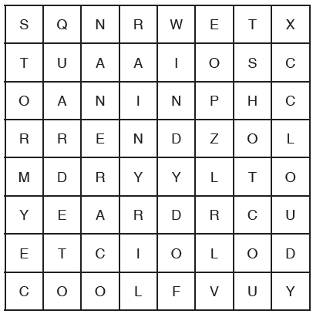

P4 ENGLISH MARKING SCHEME
- My favorite subject is English
- Keza goes to school on foot
- I sing songs at school every day
- I would like to be a pilot
- We saw a cow in the farm
- By
- In
- By
- At
- Outside
- From
- With
- to
- with
- of
- He works at the hospital
- It runs very fast
- He advised us to work hard both at school and at home
- They are brothers
- We will go to the shop
- Dad brought us very good presents
- She wanted to play volleyball with him
- The police arrested them
- The school rewarded them for the job well done
- They are playing football in the school yard
- Lice
- Women
- Boys
- Men
- Sandwiches
- Proper noun
- Common noun
- Common noun
- Common noun
- Proper nouns
- It was
- Write
- Helped
- Looked
- He will come
- Played
- Cooked
- Does
- Gave
- Goes
- A mechanic
- Hospital
- Court
- Wood
- Artist
- Sunny/rainy/windy/hot/cloudy/dry/cool/stormy/wet/

