Google Groups
Blogs
Google Docs
Slide share
Wiks
Google Maps:
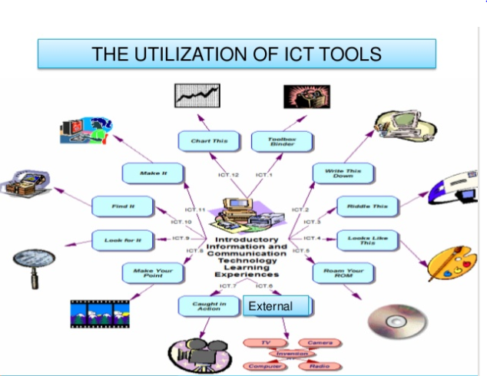
Flow this link: https://www.slideshare.net/YESVITA/ict-tools-49037225

