S 1 END UNIT EXERCISES 2020
UNIT1:
1. A science that deals with the study of human behavior and society like sociology is
a. Natural science b. social science c. formal science d. all the above
2. What is physics?
a. The study of matter in relation to energy.
b. The study of the physical quantities and their properties.
c. The study of instruments used for measurement of physical quantities.
d. The study of living and non-living things.
3. Which of the following is not a derived quantity?
a. Density b. Volume c. Speed d. Length

4. The following instruments measure length except ,
a. Tape measure b. Micrometer screw gauge.
c. Burette d. Metre rule.

5. Which of the following is not a branch of physics?
a. Mechanics b. Light c. Heat d. Engineering.
6. During the scientific investigation the stage where we use questions is
a. Data analysis b. Data collection c. Observation d. Prediction
7. The instrument used to measure density is:
a. Barometer b. Hydrometer c. Calorimeter d. Ammeter

8. ……………………..is a guest answer basing on the observation
a. Reporting b. Data analysis c. Prediction d. None of the above
9. Students were in the laboratory and accidentally fire outbreak fumes off in the class. The following are safety precautions they should apply except:
a. Move out of fire assembly points using fire exit points.
b. If you can, use the fire extinguisher to put the fire off.
c. If you can, switch off the main switch of the laboratory wiring system.
d. Pull out the victim from the appliances

10. What is your understanding of the term Hypothesis
a. The problem to be researched on.
b. The researcher’s intelligent guested answer to research question.
c. An opinion.
d. An idea.

11. Which of the following is a derived quantity?
a. Area b. Time c. Current d. Luminosity

12. The following are example of laboratory hazards except ,
a. Suffocation b. Electric shock.
c. Fire outbreak d. Eating in the laboratory

13. Which of the following is not a carrier of physics?
a. Mechanics b.Physics teacher c. Medicine d.Engineering.

14. Which one of the following is the safety precaution in the a laboratory
a. Running in the laboratory
b. Eat and chew in the laboratory
c. Use equipments with care and for their right purpose
d. Do as you wish in a laboratory
15. One of the prefix used in mass measurement is mill gram (mg), its scientific notation is:
a. 10⁻³ g b. 10⁻² g c. 10⁻⁶ g d. 10⁺³ g
16. The type of Science that deals with natural phenomena is called
a. social science b. Formal science c. logics d. Natural science .
17. Density of a substance is defined as
a. Volume per unit mass
b. Density of a substance to the density of water
c. Mass per unit volume
d. None of the above

18. Which of the following is an importance of studying physics
a. It helps in acquisition of career of well paying jobs.
b. It is the foundation on which other sciences are built
c. It finds application in many areas of our daily lives
d. all the above

19. A nanosecond is:
a. 10⁹ s b. 10⁻⁹ s C. 10⁻¹⁰ s D. 10⁻¹⁰ s E. 10⁻¹²
20. The SI base unit for mass is:
a. gram b. pound c. kilogram d. Newton e. kilopound
21. A gram is:
a. 10⁻⁶ kg b. 10⁻³ kg c. 1 kg d. 10³ kg e. 10⁶ kg
22. a student wanted to measure the thickness of the wire, which of the following instruments is more likely to use.
a. Vernier calliper b. Micrometer Screw Gauge c. Tape measure d. all the above

STRUCUTRED QUESTIONS
1. Complete the table below. 10marks

Physical quantity | S.I UNIT and Symbol | INSTRUMENT
Time | Seconds (S) | Stop watch
 | Ampere (A)
 |  | Beam balance
Density
Temperature
 | Newton (N)

2. Discuss at least any four contribution of a physicist to the development of your country.
3. What are safety precautions would you take in case electrical shock to your colleague when you are in the Physics laboratory?
4. Describe the three difference between density and relative density.

5. A cylindrical has a diameter of 4.2cm. How many times would a thread of 132 cm be wound around the cylinder?
6. The mass of a substance is 500 g and its density is 800 kg/m³.Calculate the volume of the substance and expresses the answer in cm³.
7. Read the following micrometer and Vernier caliper measurements.

a)
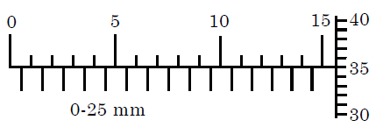

b.
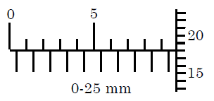

c.
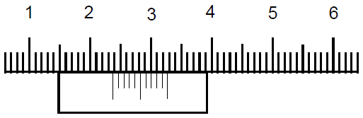

8. a. Find the total area, total volume and total mass of the block below if its density is 7.6g/cm³
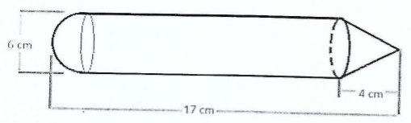
9. Drops of water coming from a crack in a water tap are collected at regular intervals as shown in Figure below
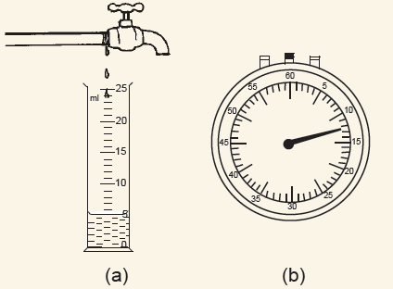

- What is the time taken to collect this volume?
- The measuring cylinder used has a capacity of 25 ml. What is the time taken to fill the measuring cylinder?

10. A Eureka can of cross sectional area 60 cm2 is filled with water to a height of 10 cm. A piece of steel is lowered carefully into the can as shown in Figure below, then removed. If the height of the water dropped to 7 cm, after overflowing, determine the volume of steel metal.

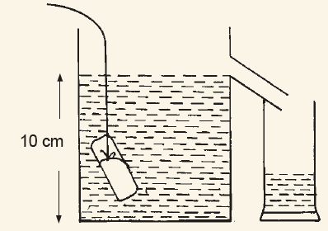

11. Describe how you would determine the volume of irregular stone using a thread, eureka can and a small graduated measuring cylinder.
12. In an experiment to determine the density of a metal a number of pieces
of the same metal are used. Their masses and corresponding volume are
with table below.

Mass ( g) | 18 | 27 | 36 | 42 | 54
Volume (cm³) | 2 | 3 | 4 | 5 | 6

a. Plot these results on a graph paper. Mass should be on y-axis and volume on
x-axis. Indicate on the graph with letter X the result which is not correct.
Draw the graph through the correct points.
b. Does your graph pass through the origin?
Explain your answer.
c. Determine the density of the metal from the graph.
Show on your graph any measurements you have made in order to determine
the density of the metal.

UNIT1: ANSWERS

PART I: M C

1 | 2 | 3 | 4 | 5 | 6 | 7 | 8 | 9 | 10 | 11 | 12
b | a | d | c | d | c | c | c | d | b | a | d

13 | 14 | 15 | 16 | 17 | 18 | 19 | 20 | 21 | 22
a | c | a | d | c | d | b | c | b | c
PARTII: STRUCTURED QUESTIONS

1.
Physical quantity | S.I UNIT and Symbol | INSTRUMENT
Time | Seconds (S) | Stop watch
Current | Ampere (A) | Ammeter
Mass | Kilogram (Kg) | Beam balance
Density | Kilogram per cubic meter(kg/m³) | Lactometer
Temperature | Kelvin (K) | Thermometer
N | Newton (N) | Spring balance

2. A physicists have much contribution the development of the country through:
- The development of radio and television, satellites has revolutionized the means of communication by physicists.
- Physicists Advance in electronics (computers, calculators and lasers) have greatly enriched the country use of I CT.
- Rapid means of transport designed by technologists and engineers are important for the society.
- They help in the Generation of power from nuclear reactors which based on the phenomenon of controlled nuclear chain reaction.
- Digital electronics is widely used in modern technological development
- The engineers and technologists design and develop devices and appliances that make our living more comfortable.
3. In case of electrical shock while in the laboratory, you must:
-Switch off the power at the socket first.
-Pull out the victim from the appliances
-Give the victim first Aid.
-If the victim is not breathing, tap three times on his/her left side of the chest
-If not breathing, ‘give a kiss of life’ (help the victim to breath)
-Seek for medical assistance from medical personnel

4.
Density | Relative density
- Density is the mass per unit volume of substance  - Density has S I unit | - Relative density is the ratio of density of substance to the density of reference ( water for solid, liquid air for gas)  -Relative density doesn’t have unit

5. Given Diameter =4.2 cm Length = 132cm
Circumference = $πD= \frac{22}{7}x 4.2 cm=13.2 cm$
No of times = $\frac{length of thread}{circumference of the cylinder}=\frac{132cm}{13.2cm}=10 times$
The thread would be wound 10 times
6. Mass =500 g Density =800 kg/m3 =0.8 g/cm3
Volume = $\frac{m}{ρ}=\frac{500}{0.8}=625{cm}^{3}$
7. a. $15mm+0.35mm=15.35mm$
b. $9.5mm+0.18mm=9.68mm$
c. $1.4cm+0.08cm=1.48cm$

8. Soln
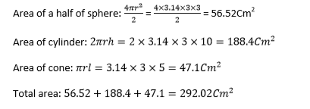
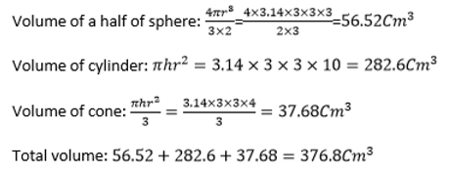
Then Mass = density x volume = 376.8 cm³ x 7.6g/cm³ = 2863. 68 g = 2.86368Kg

b. Determine the relative density of this block
Relative density= $\frac{Density of a substance}{Density of water}=\frac{7.6 g/{cm}^{3}}{1g/{cm}^{3}}=7.6$
9. a. it is 12 seconds as indicated by the clock
b. 5ml $→$ 12 s
1 ml $→$ $\frac{12}{5}$
25 ml$→\frac{12}{5}x25=60 seconds$

10.
$Volume of Eureka can=Ah=60{cm}^{2}x10cm={600 cm}^{3}$
$$Volume after over flowing= Ah=60{cm}^{2}x7cm=420{cm}^{3}$$
Volume of the steel metal = Volume of flowing water =$600{cm}^{3}-420{cm}^{3}=180 {cm}^{3}$

11.
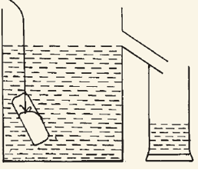
- Pour water in eureka can until full and wait until no water passing the outlet
- Place an empty small measuring cylinder under the out let of the Eureka can.
- Tie the stone with a thread and release it slowly in the Eureka can until it reaches the bottom as shown in the arrangement above
- Collect the displaced water in the small measuring cylinder
- Note the volume of collected in the measuring cylinder
- N.B The volume of water displaced is equal to volume of the stone.
12.a. a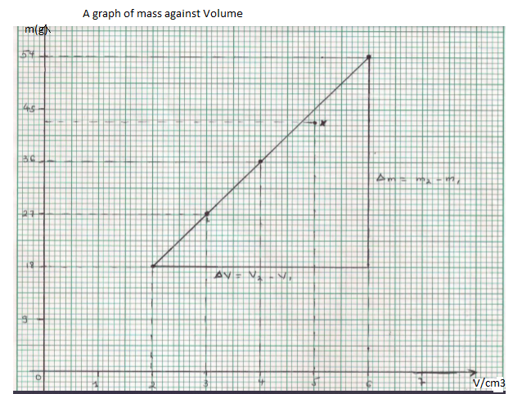

b. No, The graph doesn’t pass through the origin because we cannot find the object of mass
zero mass and volume zero also the density of that object doesn’t have meaning.
c. $ρ=\frac{∆m}{∆V}=\frac{54-18}{6-2}=\frac{36}{4}=9g/{cm}^{3}$

UNIT2: Qualitative analysis of linear motion

1. Motion on straight line is
- Circular motion b. Linear motion c. Nonlinear motion d. No one of the above
2. In uniform motion
- The speed of an object remains constant
- The speed of an object change at a constant rate
- The speed of an object increases with a time
- The speed of an object decreases with time
3. Distance is
- the length between two points in particular direction
- the length between two points along the path followed by an object
- the length between too points in shortest way
- no one of the above
4. Displacement is
- the length between two point in particular direction
- the length between point along the path followed by an object
- the length between two point in shortest way
- a and c are correct
5.Displacement is
- vector quantity b. scalar quantity c. derived quantity d. no one of above

6. The unity of distance is
- meter (m) b. meter per second (m/s) c. meter per second squared (m/s2)
d. no one of the above
7. Speed is defined as
- rate of change of distance b. rate of change of displacement
c. speed is quotient of displacement with time d. no one of the above
8. Total distance coved by the body over total time taken is
- Speed b. velocity c. average speed d. average velocity
9. The instrument used to measure the speed of car is
- speed meter b. speed governor c. stop watch d. no one of the above
10.Acceleration is
a. the rate of change of distance b. the rate of change of displacement
c. the rate of change of velocity d. no one of the above
11. The value of acceleration due to gravity in the earth is
- 1.76m/s² b. 3.8m/s² c. 9.8m/s² d. 17m/s²
12. The gradient of velocity time graph represents
- Speed b. Acceleration c. Velocity d. No one of the above
13. In a graph of distance vs. time, what does the slope of the line equal?
a. the slope of the floor b. distance traveled c. total time d. speed e. acceleration

14. What is the average velocity of a car that goes 120 m in 20 seconds?
a. 120 m/s b. 0.17 m/s c. 2,400 m/s e. 6 m/s

15. If a car is going 10 m/s and 4 seconds later it is going 18 m/s, what is its acceleration?
a. 2 m/s b. 18 m/s² c. 8 m/s² d. 2 m/s² e. 0.5 m/s

16. Which has zero acceleration? An object
  - at rest.
  - moving at constant velocity.
  - moving at a constant speed in a straight line.
  - all of these.

17. Starting from the origin, a person walks 6 km east during first day, and 3 km east the next day. What is the net displacement of the person from the initial point in two days?
A. 6 km, west ; B. 3 km, east; C. 10 km, east D. 5 km, west; E. 9 km, east
18. The diagram below illustrates a person who, starting from the origin, walks 8 km east during first day, and 5 km west the next day. Use it to answer questions (i) and (ii).

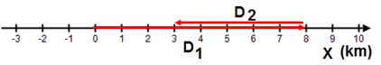
- What is the net displacement of the person from the initial point in two days?
A. 6 km, east B. 3 km, east C. 10 km, west D. 5 km, west E. 9 km, east
- What is the traveled distance of the person from the initial point in two days?
A. 13 km B. 3 km C. 10 km D. 5 km E. 9 km

19. An object moves at a constant speed of 6 m/s. This means that the object:
A. Increases its speed by 6 m/s every second
B. Decreases its speed by 6 m/s every second
C. Doesn’t move
D. Has a positive acceleration
E. Moves 6 meters every second

20. A snapshot of three racing cars is shown on the diagram below. All three cars start the race at the same time, at the same place and move along a straight track. As they approach the finish line. 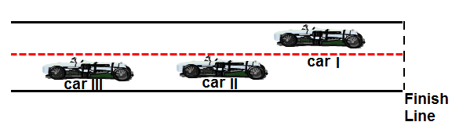
which car has the lowest average speed?
A. Car I
B. Car II
C. Car III
D. All three cars have the same average speed
E. More information is required

STRUCTURED QUESTIONS

1. a) What do you understand by the term motion of a body?
b) Mention two types of motion in mechanical system.
c) What causes motion of a body to occur.
2. a. Sketch a velocity-time graph indicating a body whose velocity increases linearly with time
b. For the objects shown in the graph, which is fastest
distance
(m)
time (s)
0 1 2 3 4 5
5
4
3
2
1
0

B
C
A

3 . What is the average velocity of someone who walks 3 km in a half hour, then 6 km in an hour and a half?

4. Differentiate between distance and displacement

5. A boat starts at point A moves 40m east to point B followed by 30m north to point C. Calculate.
a. The distance covered.
b. The displacement covered.

6. A car accelerates from rest to a velocity of 60m/s in 5seconds. Calculate its acceleration.
7. A car is brought to rest from 90km/h in 10s. what is its deceleration?

8. A body starts from rest and accelerates at 2m/s² for a time of 5sec. Calculate the distance travelled by the body.

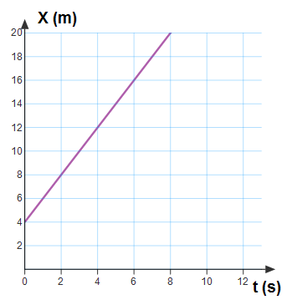
9. The following graph represents the position as a function of time of a moving object. Use this graph to answer questions on it.

a. What is the initial position of the object?
b. What is the velocity of the object?
10. The graph represents the relationship between velocity and time for an object moving in a straight line.
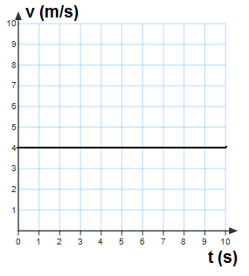
a. What is the traveled distance of the object at 9 s?
b. what is the acceleration of the object above
11. The velocity as a function of time of a moving object is presented by the graph below. Use this graph to answer questions on it.

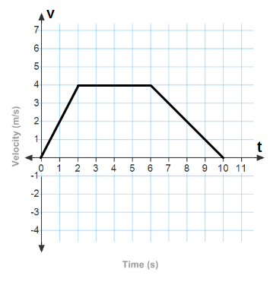

a. What is the acceleration of the object at the end of 2 s?
b. What is the acceleration of the object between 2 s and 6 s? Explain your answer
c. Is the magnitude of acceleration of the object between 6 s and 10 Positive? or Negative? why
d. In velocity- Time graph, distance can be obtained by calculating the area under the graph. How far from the origin does the object move in first 2 s?

12. The table below shows speeds of a car accelerating on a straight road.
Time/s | 0 | 2 | 4 | 6 | 8
Speed/ms⁻¹ | 0 | 5 | 10 | 15 | 20

- Plot a graph of speed on Y-axis against Time on X-axis.
- Calculate the gradient(slope) from the graph.
- What does the slope represent?
- Is the acceleration uniform or non-uniform?

ANSWERS
PART 1: MULTIPLE CHOICE

1 | 2 | 3 | 4 | 5 | 6 | 7 | 8 | 9 | 10 | 11 | 12 | 13 | 14 | 15 | 16 | 17 | 18 | 19 | 20
b | a | b | d | a | a | a | c | a | c | c | b | d | e | d | d | e | b&a | e | c

PARTII
1. a) Motion is a change in position of an object over time
b) -Circular motion; linear motion and Oscillation motion
c) Motion of a body is caused by force applied to it.
2. a
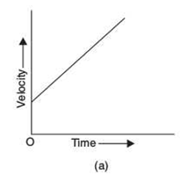
b. The fastest object is A
3. Soln $Average velocity= \frac{Total distance}{Total time}=\frac{\left(3+6\right)km}{(0.5+1.5)hr}=\frac{9 km}{2 hr}=4.5km/hr$
4.
DISTANCE | DISPLACEMENT
Scalar quantity | Vector quantity
Total length of the paths that object travels | Shortest length between object’s starting and ending point
5. a. Since distance has no direction d$=40m+30m=70m$
b.
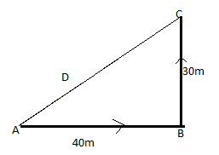
From the principle of triangle theorem $D^{2}={(AB)}^{2}+ {(BC)}^{2}$
D$\sqrt{{40}^{2}+{30}^{2}}=\sqrt{2500=} 50m$
6. $a=\frac{∆v}{∆t}=\frac{60-0}{5}=\frac{60}{5}=12m/s^{2}$
7. $a=\frac{∆v}{∆t}=\frac{0-90}{10}=\frac{-90}{10}=-9m/s^{2}$
Therefore, the deceleration is 9m/s²

8. From $s=ut+\frac{1}{2}at^{2}=0x5+\frac{1}{2}x2x5^{2}=25m$
9. a. The initial position of the object is 4 m
b. $v=\frac{∆s}{∆t}= \frac{20-4}{8-0}=\frac{16}{8}=2m/s$
10. a. Since Velocity is constant $S=vxt=4x9=36m$
b. Acceleration is Zero ( 0 m/s²) since the velocity is constant
11. a. $a=\frac{V-u}{t}=\frac{4-0}{2}=2m/s^{2}$
b. $a=\frac{V-u}{t}$= $\frac{4-4}{4}=\frac{0 }{4}=0 m/s^{2}$. This is because the velocity is constan
c. The acceleration is Negative as the object is coming to rest ( Deceleration)
d. In the first 2 sec, the area is like that of a triangle
$$S=A=\frac{1}{2}xBXH=\frac{1 }{2}x2x4=4m$$
12. a. 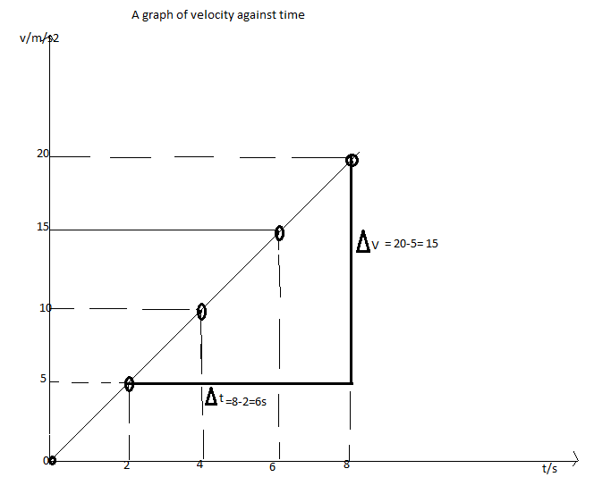

b. Gradient $=\frac{∆v}{∆t}= \frac{20-5}{8-2}=\frac{15}{6}=2.5m/s^{2}$

c. Since it is a velocity –time graph, the slope represent acceleration
d. The acceleration represented in the graph is Uniform as the slope is a straight line

